Environmental and Social Management Plan (ESMP) Checklist
for the following infrastructure investment project:

Renovation and adaptation of the Municipal Court in Vinkovci

October 2019

TABLE OF CONTENT

INTRODUCTION 1
ENVIRONMENTAL AND SOCIAL CATEGORY 3
Potential environmental and social impacts 3
ESMP CHECKLIST 4
Application of the ESMP checklist 4
MONITORING AND REPORTING 5
- Part 1: Institutional/administrative 5
- Part 2: Environmental and social screening 7
- Part 3: Monitoring plan 10
Reporting 12
Annex 1: Renovation and adaptation of the Municipal Court in Vinkovci 14
Annex 2: Land register entries - Vinkovci 15
Annex 3: Capacity for maintenance and monitoring the compliance
with the environmental policies 16
Annex 4: Cultural Heritage Management Plan 18
Annex 5: Special conditions for the protection of immovable cultural heritage 22

Introduction
The Justice for Business Project (Just-B) main objective is to increase overall quality of regulatory procedures as well as efficiency of the judiciary services in Croatia. The project has two components. Component 1. is related to improving the business environment and the quality and efficiency of judicial services, which are expected to reduce the administrative burden for businesses to interact with government. Component 2. is an investment component that will finance improvements in the justice sector infrastructure management, including the rehabilitation and renovation of selected court facilities. This is expected to contribute to improved quality of judicial services to businesses and other users. Initiatives to be supported under the two components are aligned with, and complement, the Government’s 2019 NPR priorities and other ongoing activities.
Amongst other things, JUST-B Project supports physical rehabilitation of up to four courts in Croatia, selected based on the following criteria: i) level of caseload, ii) level of business activity, and iii) focus on the lagging regions. Amongst other locations, the selected locations include judicial facility in Vinkovci.
The upgrade of selected court facilities will focus on improving the internal workflow in court registries and archives, enhancing the user interface and accessibility (including for disabled persons); the refurbishing of judge’s chambers, and courtrooms; and the upgrading of energy efficiency standards (building envelope, heating and cooling system). There will be no change in the building footprints in Vinkovci. However, the building is a cultural heritage protected facility with local significance which requires a specific national regulation and World Bank’s (WB) standards sub-project scrutiny.
Energy efficiency is an indicator of technological development and energy awareness, influencing economic, environmental and social development of the entire society. The Ministry of Justice (MoJ) of the Republic of Croatia aims to reduce energy intensity, which indirectly affects competitiveness and sustainable development.
At the project concept stage, environmental and social risk is assessed as moderate as the planned civil works are predominately linked to rehabilitation of four existing court buildings. Given that these are general and small-scale construction activities, the potential adverse risks and impacts on human population and/or the environment are not likely to be significant. This is because the project activities are neither complex nor large, do not involve activities that have a high potential for harming people or the environment, and all of the project sites are located away from environmentally or socially sensitive areas. As such, the potential risks and impacts are (i) predictable and expected to be temporary and/or reversible; (ii) low in magnitude; (iii) site-specific, without likelihood of impacts beyond the actual footprint of the project; and have (iv) low probability of serious adverse effects to human health and/or the environment.
These impacts most commonly include: a) dust and noise due to excavation, demolition and construction; b) management of demolition / construction wastes and accidental spillage of machine oil, lubricants, etc.; c) possible management of small amount of hazardous materials like asbestos or paints and varnishes; d) traffic disturbance; e) small scale surface or ground water pollution; f) soil pollution or erosion; g) workers, vendors and employers safety; and h) impacts on cultural heritage sites and in some cases, although quite unlikely, cultural heritage chance finds. In addition, special attention to safety of employees, other users of the building and visitors will be put through mitigation measures as some of the works might go in parallel with the court operation. The project’s risks and impacts can be easily mitigated in a predictable manner through good construction practice, environmental permitting process and through implementation of ESMP Checklist.
The planned rehabilitation works will foster a work-friendly environment for judicial staff and support improvements of judicial services for business; improve the performance of the court and create better working environment for judicial personnel and enhance service delivery to Croatian citizens. The planned rehabilitation and renovation works will foster a more user-friendly environment for residents of Vinkovci and the provision of judicial infrastructure upgrades and improved access to judicial services and quality infrastructure would be of great benefit to the residents.
Cultural heritage related risks will be addressed through the development of Cultural Heritage Management Plan (CHMP) annexed to this ESMP Checklist with integrated conditions obtained in opinions and permits of competent authorities for interventions into physical cultural heritage.

Environmental and Social Category
The project aims for renovation and adaptation of the non-residential building of the Municipal Court in Vinkovci at the address: Trg Bana Josipa Šokčevića 17; built on cadastral particle 2613/2 cadastral municipality Vinkovci. The tender procedure for preparing a design for an energy efficiency project is completed, envisaging a preliminary design to be developed within a year. The refurbishment of the attic into offices and the instalment of a new elevator in the back yard, both to be financed by the WB loan, will require a construction permit. No interventions to the heating system are planned. No asbestos material is present in the building or used at the time building was built.
Given the level of preparation, extensive legislative framework, our technical knowledge, experience and because of construction related activities which are in general of limited impact, the environmental and social risk is assessed as moderate.

Table 1 Sub project environmental and social screening table
Types of moderate risk activities | Environmental Assessment documentation required | Applicable to:
1 | Environmental and Social Management Plan Checklist (ESMP Checklist) intended for typical works in predictable environment for each individual construction (sub-project) | Vinkovci, Varaždin, Kutina and Zagreb sub-projects

Potential environmental and social impacts
The environmental impacts of the above described infrastructure investment project are expected to be of manageable, temporary and of local impact typical for civil works as they are related to the general construction activities on already known and urbanized locations. These impacts include dust and noise due to excavation, demolition and construction; management of demolition construction wastes and accidental spillage of machine oil, lubricants, etc., encroachment to a private property; occupational health and safety risks (OHS), and traffic disturbance while potential damage to historical or cultural property or unknown archaeological sites will be addressed in the annexed CHMP.
Social risk is assessed as moderate as the planned civil works will be site-specific with no impacts beyond the footprint of the existing court building. No land acquisition will be required, and the works to be performed are small in magnitude and as such the impacts can be easily and predictably mitigated. Risk related to labor influx is minimal as rehabilitation works are of small-scale nature. Regular operation and functioning of the court will remain during the planned works so the users/ beneficiaries will have a continuous and uninterrupted access to judicial services.

ESMP CHECKLIST
The ESMP Checklist is applied for minor rehabilitation or small-scale building construction, especially in education, health and public service reconstruction sector. It provides “pragmatic good practice” and it is designed to be user friendly and compatible with WB safeguard requirements. The checklist-type format attempts to cover typical mitigation approaches to common civil works contracts with localized impacts.
The checklist has one introduction section and three main parts:
- Introduction or foreword part in which the project is introduced, environmental category defined, and ESMP Checklist concept explained.
- Part 1 constitutes a descriptive part (“site-passport”) that describes the project specifics in terms of physical location, the institutional and legislative aspects, the project description, inclusive of the need for a capacity building program and description of the public consultation process.
- Part 2 includes the environmental and social screening in a simple Yes/No format followed by mitigation measures for any given activity.
- Part 3 is a monitoring plan for activities during project construction and implementation. It retains the same format required for standard World Bank ESMPs. It is the intention of this checklist that Part 2 and Part 3 be included as bidding documents for contractors.

Application of the ESMP Checklist
The design process for the envisaged infrastructure investment projects in judiciary will be conducted in three phases:
- General identification phase, in which the object (court) for renovation and adaptation is described. At this stage, Part 1, 2 and 3 of the ESMP Checklist are filled. Part 2 of the ESMP Checklist can be used to select typical activities from a “menu” and relate them to the typical environmental issues and mitigation measures.
- Detailed design and tendering phase, including specifications and bills of quantities for individual objects. The ESMP Checklist is revised according to the detailed design at this stage. As such, the Checklist is presented to the public, prior to the tendering procedure. This phase also includes the tender and award of the works contracts. The whole filled in tabular ESMP Checklist (Parts 1, 2 and 3) should be additionally attached as integral part to the works contract as well as supervision contract, analogous to all technical and commercial terms, has to be signed by the contract parties.
During the works implementation phase environmental and social safeguard compliance is checked on the respective site by the site certified inspector(s) / authorized works supervisor(s), which include the site supervisory engineer and architect surveillance hired by the MoJ of the Republic of Croatia and other relevant inspection services. The mitigation measures in Part 2 and monitoring plan in Part 3 are the basis to verify the Contractor’s compliance with the required environmental provisions.

MONITORING AND REPORTING
PART 1: INSTITUTIONAL/ADMINISTRATIVE
Country | Republic of Croatia
Project title | Renovation and adaptation of the Municipal Court in Vinkovci
Scope of project and activity | The objective of the project is to improve the working conditions of selected judicial bodies, make them more energy efficient, functional and in line with MoJ’s vision of the modern judiciary. The project will support renovation and adaptation of the Municipal Court in Vinkovci
Institutional arrangements  (Name and contacts) | Project management
 | Ministry of Justice of the RoC  General Secretary  (Sector for finance and public procurement)  Directorate for Strategic Development, Informatization and Capital Investments in Judiciary  Responsible for the preparation of the ESMP, public consultation of the ESMP and procurement of works and site supervising engineer  Team designated for procurement of designs, coordination of implementation of POM environmental and social related issues which among others include Checklist ESMP supervision  Responsible for supervision of Checklist ESMP implementation | Contractor  (name needs to be updated after contracting)  Responsible for the implementation of mitigation measures and monitoring according to Parts 2 and 3 of Checklist ESMP
Implementation arrangements  (Name and contacts) | Supervision
 | Ministry of Justice of the RoC  Responsible for contracting site supervising engineer and occasional site supervision  Supervising site engineer  (name needed to be updated after contracting)  Responsible for monitoring of implementation of the ESMP Checklist from constructor side. | Local Inspectorate from various public administrative bodies  Responsible for occasional visits to the site or upon public complaint
SITE DESCRIPTION
Name of site | Municipal Court in Vinkovci
Describe site location | Municipal Court in Vinkovci | Annex 1: Site information (figures from the site) [X]Y [] N  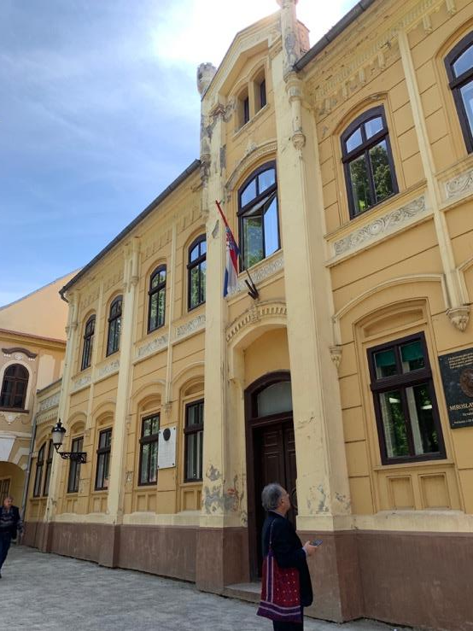
 | The court building is located in the urbanized area. Given the long and rich history of the area, the large ratio of the city is in a degree of archeological protection. The building of Municipal Court is located within zone "A" of the protected cultural and historical unit of the city of Vinkovci and within zone "A" of the protected Archaeological zone Vinkovci (reg. No. Z-447) which are entered in the Register of Cultural Property - List of Protected Cultural Property.
Who owns the land? | Land and buildings are owned by the Republic of Croatia  (see Annex 2)
Geographic description | Vinkovci: The City of Vinkovci is located in the furthermost northeast of Croatia, between rivers Danube and Sava, situated along the river Bosut. The city and its environs are positioned at 78-125 metres above sea-level, covering the area of 102,805 hectares.
LEGISLATION
Identify national & local legislation & permits that apply to project activity | Physical Planning Act (OG 153/13, 65/17, 114/18, 39/19), Building Act (OG 153/13, 20/17, 39/19), Building Inspection Act (OG 153/13), Act on Physical Planning and Building Tasks and Activities (OG 78/15, 118/18), Energy Efficiency Act (OG 127/14, 116/18), Technical regulation on energy economy and heat retention in buildings (OG 128/15, 70/18, 73/18 Correction, 86/18 Correction), Ordinance on energy audits and energy certification of buildings (OG 88/17), Law on the Protection and Preservation of Cultural Property (OG 69/99, 151/03, 157/03 Correction, 87/09, 88/10, 61/11, 25/12, 136/12, 157/13, 152/14, 98/15, 44/17, 90/18)
PUBLIC CONSULTATION
Identify when / where the public consultation process took place | The ESMP Checklist will be disclosed in English and Croatian for 14 days on the Project’s and Court’s site accompanied by an informative call for comments to public containing fax number, email and postal address to which comments and questions can be sent. A hard copy will be made available to the interested public at the Court’s reception and the notice board in the same period. The final version of the ESMP Checklist will include relevant stakeholder comments. All questions must be adequately addressed, and feedback provided.
INSTITUTIONAL CAPACITY BUILDING
Will there be any capacity building? | [ ] N or [ X ]Y if Yes, Annex 3 includes the capacity building information

PART 2: ENVIRONMENTAL AND SOCIAL SCREENING

Will the site activity include/involve any of the following: | Activity | Status | Additional references
 | - Building rehabilitation | [X] Yes [] No | See Section B below
 | - New construction | [] Yes [X] No | See Section B below
 | - Individual wastewater treatment system | [] Yes [X] No | See Section C below
 | - Historic building(s) and districts | [X] Yes [] No | See Section D below
 | - Acquisition of land | [] Yes [X] No | See Section E below
 | - Hazardous or toxic materials | [] Yes [X] No | See Section F below
 | - Impacts on forests and/or protected areas | [] Yes [X] No | See Section G below
 | - Handling/management of medical waste | [] Yes [X] No | See Section H below
 | - Traffic and Pedestrian Safety | [X] Yes [] No | See Section I below

ACTIVITY | PARAMETER | MITIGATION MEASURES CHECKLIST
A. General Conditions | Notification and Worker Safety | - All required permits have been obtained  - The local construction and environment inspectorates and communities have been notified of upcoming activities  - The public has been notified of the works through appropriate notification in the media and/or at publicly accessible sites (including the site of the works)  - All legally required permits have been acquired for construction and/or rehabilitation  All work will be carried out in a safe and disciplined manner designed to minimize impacts on neighboring residents and environment  - Working temporary infrastructure (e.g. scaffolds) and Workers Personal Protective Equipment (PPE) will comply with international good practice (always hardhats, as needed masks and safety glasses, harnesses and safety boots).  - Appropriate signposting of the sites will inform workers of key rules and regulations to follow  - The workers are adequately trained, certified (e.g. for working at heights) and experienced for the work performed.  - Fire prevention and fire protection measures are in place. Workers are well informed and trained to use the available equipment.  - Emergency procedures are in place and known to workers.  - Rehabilitation of Archives is designed to meet requirements of the national OHS legislation, Law on Fire Protection, Law on Archives and Archived Materials and other applicable legislation.  - Design of archives will ensure sufficient light for employees working in the archives, prevention of flooding (from the outer gutters), strive to minimize dust and provide adequate ventilation.
B. General  Rehabilitation and /or Construction Activities | Air Quality | - During interior demolition use debris-chutes above the first floor  - Keep demolition debris in controlled area and spray with water mist to reduce debris dust  - Suppress dust during pneumatic drilling/wall destruction by ongoing water spraying and/or installing dust screen enclosures at site  - Keep surrounding environment (sidewalks, roads) free of debris to minimize dust  - There will be no open burning of construction /waste material at the site  - There will be no excessive idling of construction vehicles at sites  - Measures (e.g. screens) will be taken to prevent spreading dust in operating parts of the Court as well as prevent dusting and damage to archives.
 | Noise | - Construction noise will be limited to restricted times agreed to in the permit and the Regulation on the Maximum Permissible Noise Levels in the Environment in which People Work and Live  - During operations the engine covers of generators, air compressors and other powered mechanical equipment should be closed, and equipment placed as far away from residential areas as possible
 | Water Quality | - The site will establish appropriate erosion and sediment control measures such as e.g. hay bales and /or silt fences to prevent sediment from moving off site and causing excessive turbidity in nearby streams and rivers
 | Waste management | - Waste collection and disposal pathways and sites will be identified for all waste types expected from demolition and construction activities. Main waste fractions will be separately collected. Sufficient number of disposal containers will be available at site.  - Mineral construction and demolition wastes will be separated from general refuse, organic, liquid and chemical wastes by on-site sorting and stored in appropriate containers  - Construction waste will be collected and disposed/reused in accordance with the national legislation by licensed collectors only to the licensed facilities/landfills or to the licensed processing installations.  - The records of waste disposal/processing will be maintained as proof for proper management as designed  - Whenever feasible the contractor will reuse and recycle appropriate and viable materials (except asbestos and other hazardous materials)
C. Individual wastewater treatment system | Water Quality | - The approach to handling sanitary wastes and wastewater from building sites (installation or reconstruction) must be approved by the competent authorities  - Before being discharged into receiving waters, effluents from individual wastewater systems must be treated in order to meet the quality criteria set out by national guidelines on effluent quality and wastewater treatment  - Monitoring of new wastewater systems (before/after) will be carried out in line with the legislation and water management conditions issued by the competent authority.
D. Historic building(s) | Cultural Heritage | - If the building is a designated historic structure, very close to such a structure, or located in a designated historic district, notify and obtain approval/permits from competent authorities and address all construction activities in line with local and national legislation. The works must comply with the obtained conditions. Any changes in the design will trigger updating of the obtained conditions.  - The contractor must be licensed and experienced in the works on historical buildings  - The works will be supervised daily by a competent person  - Artifacts or other possible “chance finds” encountered in excavation or construction are noted, officials contacted, and works activities ceased or modified to account for such finds. The works may recommence only with the approval of the competent cultural/historical heritage authorities
E. Acquisition of land | Land Acquisition Plan/Framework | - If expropriation of land was not expected and is required, or if loss of access to income of legal or illegal users of land was not expected but may occur, than the Bank Task Team Leader is consulted  - The approved Land Acquisition Plan/Framework (if required by the Project) will be implemented
F. Toxic Materials | Asbestos management | - If asbestos is located on the Project site, mark clearly as hazardous material  - The asbestos will be appropriately contained and sealed to minimize exposure  - The strong-bound asbestos prior to removal will be treated with a wetting agent to minimize asbestos dust. In the case of soft-bound asbestos is found, Wb will be informed immediately and the area will be sealed off. Works will re-commence after ESMP Checklist is updated for specific measures for asbestos removal in line with the national legislation and best practices (e.g. three chamber decontamination entrance).  - Appropriate PPE must be worn, including impermeable protective overalls, at least P2 respiratory masks (for strong-bound).  - Asbestos will be handled and disposed by licensed, skilled and experienced professionals  - If asbestos material is be stored temporarily, the wastes must be securely enclosed inside closed containments and marked appropriately  - The removed asbestos will not be reused
 | Toxic / hazardous waste management | - Temporarily storage on site of all hazardous or toxic substances will be in safe containers labeled with details of composition, properties and handling information  - The containers of hazardous substances should be placed in a leak-proof container to prevent spillage and leaking  - The wastes are transported by specially licensed carriers and disposed in a licensed facility. Hazardous liquids will not be mixed.  - Paints with toxic ingredients or solvents or lead-based paints will not be used
G. Affects forests and/or protected areas | Protection | - All recognized natural habitats and protected areas in the immediate vicinity of the activity will not be damaged or exploited, all staff will be strictly prohibited from hunting, foraging, logging or other damaging activities  - For large trees in the vicinity of the activity, mark and cordon off with a fence large tress and protect root system and avoid any damage to the trees  - Adjacent wetlands and streams will be protected, from construction site run-off, with appropriate erosion and sediment control feature to include by not limited to hay bales, silt fences  - There will be no unlicensed borrow pits, quarries or waste dumps in adjacent areas, especially not in protected areas
H. Disposal of medical waste (not applicable) | Infrastructure for medical waste management | - In compliance with national regulations the contractor will insure that newly constructed and/or rehabilitated health care facilities include sufficient infrastructure for medical waste handling and disposal. This includes and not limited to:  - Special facilities for segregated healthcare waste (including soiled instruments “sharps”, and human tissue or fluids) from other waste disposal;  - Appropriate storage facilities for medical waste are in place; and  - If the activity includes facility-based treatment, appropriate disposal options are in place and operational
I. Traffic and Pedestrian Safety | Direct or indirect hazards to public traffic and pedestrians by construction activities | - In compliance with national regulations the contractor will insure that the construction site is properly secured, and construction related traffic regulated. This includes but is not limited to:  - Signposting, warning signs, barriers and traffic diversions: site will be clearly visible, and the public warned of all potential hazards  - Traffic management system and staff training, especially for site access and near-site heavy traffic. Provision of safe passages and crossings for pedestrians where construction traffic interferes. No parking will be allowed near scaffolds and works.  - Adjustment of working hours to local traffic patterns, e.g. avoiding major transport activities during rush hours or times of livestock movement. Works will also be adjusted to working hours of the court to minimize disturbance of employees.  - Active traffic management by trained and visible staff at the site, if required for safe and convenient passage for the public  - Ensuring safe and continuous access to office facilities, shops and residences during renovation activities, if the buildings stay open for the public

PART 3 : MONITORING PLAN
 | What | Where and what | How | When | Why | Cost | Who
Phase | (Is the impact or related action to be monitored?) | (Is the parameter if applicable to be monitored?) | (Is the parameter to be monitored?) | (Define the frequency / or continuous?) | (Is the parameter being monitored?) | (If not included in project budget) | (Is responsible for monitoring?)
During activity preparation | Current valid Permits for the duration of works | On site assessment | By checking weather all permits according to the law are available on site (e.g. location permit, construction permit) | Prior construction works commence | It is recommended to make sure that all good practices apply | Should be part of the project budget | Site supervising engineer
 | Site organization | On site visual checks | By checking proper fencing, installation of temporary sanitary facilities | Prior construction works commence | To make sure that the site is safe for workers and inhabitants | Contractor bears full cost, usually is not identified as separate category | Site supervising engineer
During  activity implementation | Air quality | Particulate matters, dust at the site | Visual observation¸ measuring air quality (PM10) in the case of complaints of Court employees and local population. | Continuous on a daily basis, however special attention should be put during transport of material and excavation works | To keep the dust level at minimum to protect health and prevent irritations and to keep visibility for safety purposes | Contractor bears full cost, usually is not identified as separate category in bill of costs | Site supervising engineer, Municipality
 | Noise | Noise concentration (db) at the site and neighborhood | Sound level meters, noise meters or equivalent instruments for measuring noise | In the first week of the construction and at the end of works; also, anytime when the site supervising engineer receives, or contractor receives a complaint from local population | To ensure noise levels are at legally acceptable level | Part of the regular contractor cost | Contractor, site supervising engineer
 | Architectural artifacts | On site visual assessment | Full supervision by site supervising engineer during excavation works | During excavation works for foundations | To prevent degradation of potential archeologically important artifacts | Part of the supervising engineer and contractor cost | Supervising site engineer. Municipality, Inspection
 | Toxic / Hazardous material | On site visual assessment | Proper handling and storage is checked according to Material Safety Data Sheets (MSDS) | Continuously | To prevent accidental spilling or injuries | Part of the regular contractor cost | Supervising engineer costs, Inspection
 | Sanitary water collection | On site; standard parameters | Visual observation; use of kit tests; samples when applicable | Based on which authorized company is called for cleaning | To prevent accidents | Part of the regular contractor cost | Supervising engineer costs, Inspection
 | Workers safety | On site | Random safety inspection | Continuously checking that appropriate protective equipment is used | To prevent accidents | Part of the regular contractor costs | Supervising engineer costs, Inspection
 | Hazard to public traffic and pedestrian safety | On site and on roads permitted to use for accessing site, traffic plans | Visual observation and potential complains from the public | Daily checking the signs, fences, accesses and traffic signalization and patterns | To prevent traffic disruption and accidents | Part of the regular contractor costs | Supervising engineer costs, Inspection, Consultants
During activity supervision | Toxic / Hazardous material management | On construction sites | Proper handling and storage is checked according to MSDS material sheets | Continuously, i.e. on a weekly basis and especially when new material is received | To prevent accidental spilling and injuries | Part of the operating costs | Work safety Inspection
 | Waste management | Premises | Waste is separately collected and disposed in line with the national regulation; Waste accompanying documentation that is submitted to Ministry of Environment in which type and quantities of the waste are identified | Continuously, i.e. during operation | Required by series of regulation on waste | Part of the regular operation costs | Ministry of Environment (inspection)
 | Air quality | Archives operate in line with the national OHS legislation and Law on Archives and Archived Materials | Parameters defined in the national legislation | Continuously, i.e. during operation | Required by series of regulation | Part of the regular operation costs | Work safety Inspection; Ministry of Culture
 | Fire-protection | Fire-prevention and protection is in place; Archives and rest of premises | Fire-prevention and protection is in place and easily accessible; alarming system is tested and operational | Regularly, in line with the national legislation | Required by series of regulation | Part of the regular operation costs | Work safety Inspection; Ministry of Culture

Reporting
Reporting is an integral part of the monitoring process as it provides valuable insight into project processes as well as decision-making information to the Project Implementation Unit (PIU) and WB teams. Consequently, it enables timely interventions and adjustment of corrective measures. The supervising engineer or the designated responsible person will report on ESMP Checklist (including CHMP) implementation to the PIU, quarterly. In the case of significant non-compliance, the PIU will, without delay, inform the WB Environmental Specialist of the nature, size, and scope of the impact. Unless differently agreed with the WB Environmental Specialist, the PIU will report ESMP Checklist implementation compliance in regular progress reports and upon request of WB Environmental Specialist.
In the case the Contractor breached the measures defined ESMP Checklist and/or applicable national regulation, and incompliance is confirmed, the PIU must propose corrective measures as well as the timeframe (deadline) for the implementation. If the corrective measures are not implemented and compliance criteria does not met within the defined timeframe, the PIU can consider withholding the payment until the Contractor responses to these requirements and requests and compliance is accomplished and re-confirmed (either through a location inspection or desk review).

Annex 1: Renovation and adaptation of the Municipal Court in Vinkovci
Court building of the Municipal Court in Vinkovci is built over 150 years ago. It is protected as a cultural heritage monument and subject to fulfilling of conservatory requirements. The objective of the project is to preserve the cultural heritage, increase office space to accommodate more judges’ chambers, streamline court registries and records for better work organization and access by users, and improve energy efficiency and access for people with reduced mobility.
For the Municipal Court in Vinkovci, project documentation is under development along with the permits that will be obtained. A complete renovation of the existing building is planned with a focus on the attic, which is currently not operational. Also, the installation of an elevator will be undertaken.

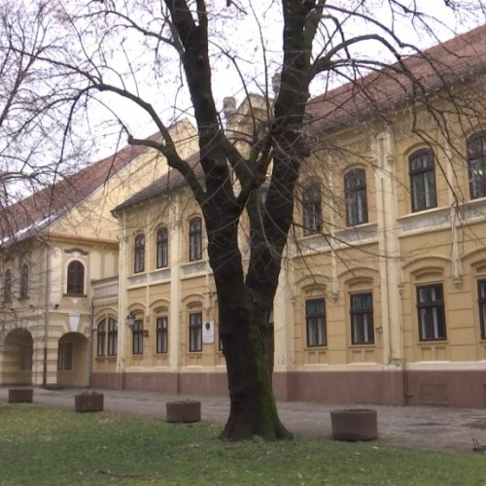
Annex 2: Land register entries - Vinkovci
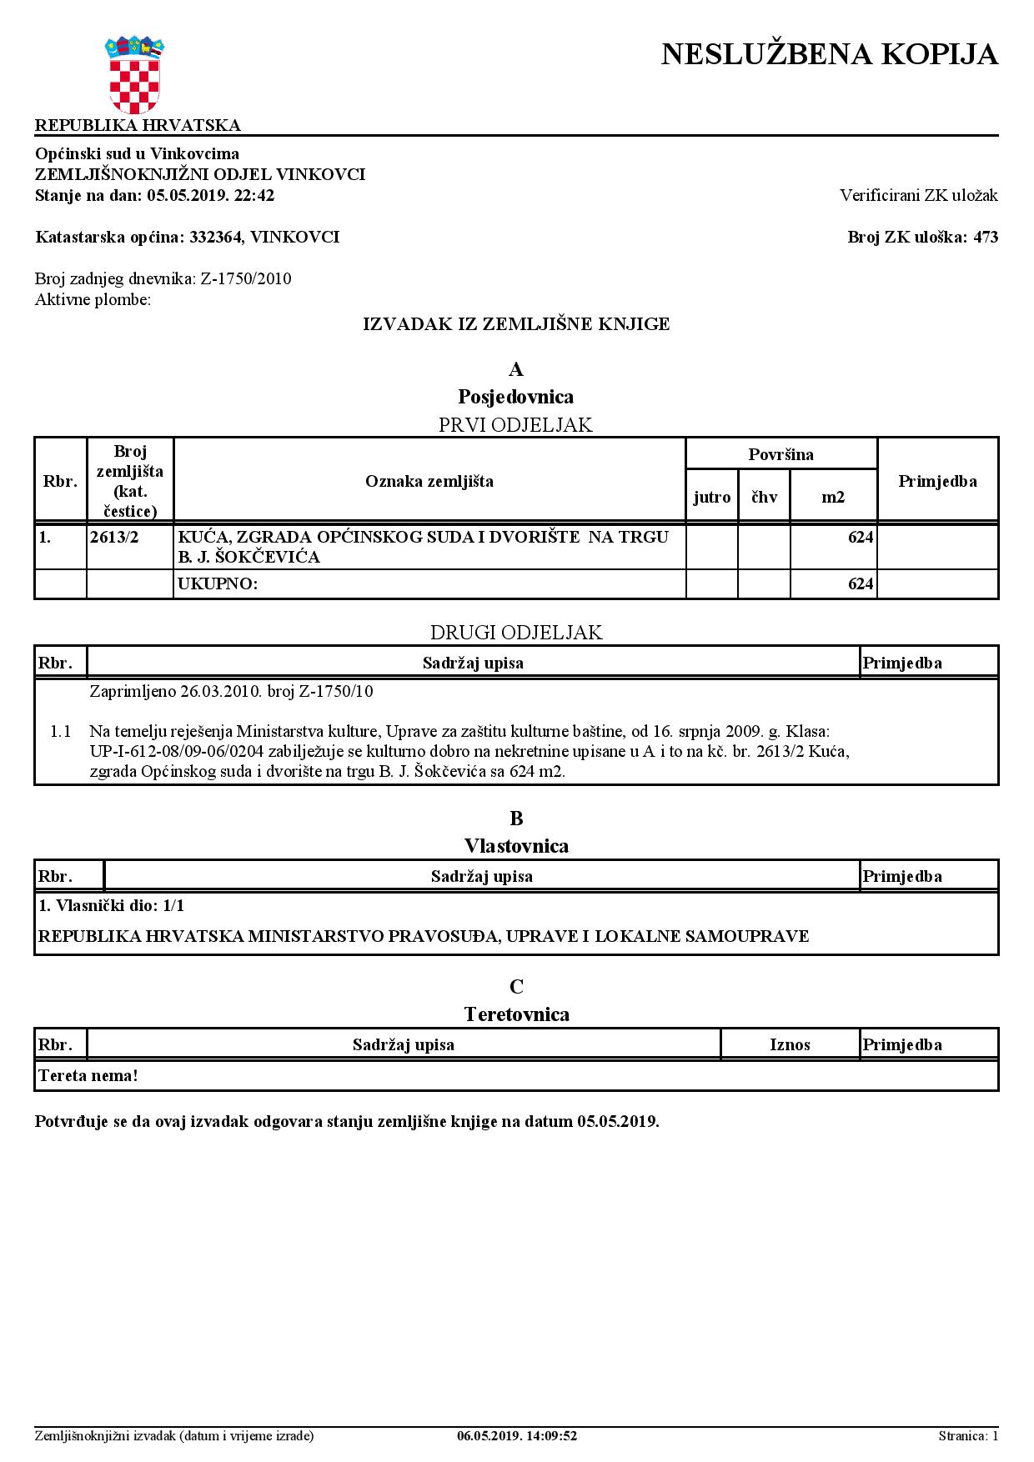

Annex 3: Capacity for maintenance and monitoring the compliance with the environmental policies
Ministry of Justice of the Republic of Croatia will establish a protocol defining all obligations of the final beneficiaries of judicial and criminal bodies related to the conditions of maintaining the building and consequently affecting the lifetime of building use and the viability of output components. The draft protocol foresees that End Users follow the state of the building, carry out periodic inspections of the building, plan the tasks related to the maintenance and improvement of the essential requirements of the building, and are obliged to entrust these tasks to persons who fulfil the conditions for carrying out the activities prescribed by the Building Act (OG 153/13, 20/17, 39/19). Maintenance in terms of planned operations is divided into:
- regular maintenance and improvement;
- emergency repairs;
- necessary repairs and
- other (issues of building security and replacement and installation of new parts and appliances).

For more effective management of human, material and financial resources, a unique IT Solution (ERP - Enterprise Resource Planning) for human resources management, property management and financial-material business for the entire judicial system will be introduced (within the project “Improvement and Modernization of the Judicial System in the Republic of Croatia - PROJECT ONE", as part of the OP Effective Human Resources). Planned IT solution also connects to asset review (white paper), property management system analysis and data entry for the judicial administration.
In accordance with the Regulation on the Internal Organization of the MoJ, the Department for Strategic Development and Projects within the Directorate for Strategic Development, Informatization and Capital Investments in the Judiciary performs, inter alia, professional tasks related to the preparation, elaboration, implementation, supervision and coordination of projects financed by programs of the European Union, bilateral projects and projects funded by the funds of international organizations, international financial institutions and the budget of the Republic of Croatia.
The Project Preparation Service performs many expert and complex activities related to the use of funds and the preparation of projects funded by the European Union, international financial institutions and bilateral sources. Project Preparation Service of MoJ (among other things):
- coordinates the preparation, proposal and drafting of project summaries;
- participates in the development of tender documents, announcements and tenders for the procurement of works, goods and services;
- coordinates the work of the units of the MoJ and other judicial bodies involved in the preparation of projects;
- etc.

The Project Implementation Service carries out activities related to the implementation and monitoring of project activities funded by the European Union, international financial institutions and bilateral sources (including the World Bank loan).

MoJ has experience in managing, coordinating and planning project activities, solving problems, making decisions, managing risks and human resources and reporting on the project. In addition to the project leader, a project administrator, accounting and finance officer and a public procurement expert will be appointed.

In conclusion, according to the mentioned Building Act (OG 153/13, 20/17, 39/19), the MoJ is obliged to contract supervision of works to ensure technical and professional control of the project for the whole time of the execution of all planned infrastructure works of the court in Vinkovci.

Given the context above and requirements of the ESMF, the MOJ responsibility within Component I will include the following activities:
- supervise the implementation of the Checklist ESMP and report on the same.
- supervise the work performed by engineering/design companies, supervisors and contractors to ensure that they are applying adequate standards and are following agreed procedures, as well as the agreed environmental plan.
- include ESMP Checklist (with CHMP) in the bidding and contracting documentation.
- organize tendering procedures, review tender evaluation performed by the architectural/engineering firms and arrange for the contracts to be signed in accordance with agreed procedures.
- designate a team for the construction and environmental issues in the Directorate for Strategic Planning, Informatization and Capital Investments within the MoJ.
- Organize reporting as defined in the ESMP Checklist (including CHMP).

After finalizing the construction, the main responsibility of monitoring will fall under the MoJ and selected judicial bodies.

Annex 4: Cultural Heritage Management Plan (CHMP)
In previous reconstructions of court facilities, the Ministry of Justice of the Republic of Croatia has had excellent co-operation with the relevant conservation (cultural heritage) departments and actively cared for the preservation of the architectural heritage of the Republic of Croatia in the domain of the judiciary. For example, we can mention the works that were carried out on the buildings of the County Courts in Sisak and Osijek within the IPA TAIB 2011 "Supporting the Rationalization of the Court Network" project as well as County Court in Pula renovated within "Justice Sector Support Project", financed from the WB funds. Works were conducted in accordance with the particular cultural heritage conditions, conservation-restoration expertise studies and by using materials and techniques approved by amenable conservation (cultural heritage) departments.
As for renovation and adaptation of the non-residential building of the Municipal Court in Vinkovci is concerned, Ministry of Justice obtained special conditions for the protection of immovable cultural heritage from the Ministry of Culture Conservation Office in Vukovar (Ministarstvo kulture, Uprava za zaštitu kulture, Konzervatorski ured u Vukovaru KLASA: 612-08-16-23/1886, URBROJ: 532-04-02-19/4-16-3 from 22nd of April 2016).
The court is located in the city square and was built as a taller building in 1868 when it received a historicistic facade in the spirit of romanticism. The second floor is a rectangular floor plan. The facade is divided by wide columns on four fields in which two windows and extended details of decorative profiles that end on the ground floor with the form of a flame are placed. The central part is lightly exposed with a wooden door, a segmented ribbon belt, and the roof area with a mansard window (a window-bifore). The facade of the building is covered with horizontal joints.
CHMP measures
Phase | Mitigation measure | When should the measure be implemented | Implementation responsibility
During activity preparation | Preparing a project that covers all planned works (construction, crafts, restoration, design) | At the project preparation stage before the implementation and reconstruction stage begins | PIU
During activity design | Consultations with the Ministry of Culture Conservation Office in Vukovar are mandatory. | Design | Designer
All phases | All works must be carried out by Contractors with a valid license for works on cultural heritage issued by the Ministry of Culture. | All phases | PIU, contractor
During activity preparation | Make architectural site condition record in 1:50 scale with details of façade and façade ornamentation in 1:1 and 1:10 scale in print and digital form. This also includes design/blueprints of carpentry and hardware, construction details, technical description and photo documentation which will be used as basis for design of the current and future architectural plans.  Prior to the design of architectural plan, the architectural site condition records (in digital and hard copy) must be verified by the Ministry of Culture Conservation Office in Vukovar. | At the project preparation stage before the implementation and reconstruction stage begins | Authorized architect; recording and design scope should be consulted with the Conservation Department in Vukovar, Supervisor
All phases | The entire building will be rehabilitated in accordance with its original exterior design recorded in old photographs, archive documentation and preserved elements. | All work phases | Designer, contractor, supervisor
During activity  implementation | Prior to removal of plaster, the manufactured façade ornamentation will be removed and stored it in a protected location for reconstruction. Coloured layers of façade and carpentry will be inspected/studied. | Before the plastering | Designer, contractor, supervisor
During activity  implementation | Dry and cemented plaster of the facade and interior should be removed; new plastering should be carried out by industrial system of high-pressure remedial plaster with smooth finish without roughcasting. Façade will be painted lime-based or silicate-based paint in colour approved by the Ministry of Culture Conservation Office in Vukovar. | During the plastering | Designer, contractor, supervisor
During activity  implementation | Keeping as much old exterior and interior carpentry as possible with necessary repairs; replace worn-out joinery with facsimile in materials, details and finishes. Preserving the original hardware. | During the joinery repairs | Designer, contractor, supervisor
During activity  implementation | Rearranging the attic into an office space is allowed; roof windows can be installed solely on the courtyard doorway as recumbent windows following the line of the roof. | During the roof works | Designer, contractor, supervisor
During activity  implementation | Covering the roof with a straight clay pepper tile in natural colour. Roof tin and facade cladding must be made of zinc or zinc plated sheet, of minimal functional dimensions. | During the roof works | Designer, contractor, supervisor
During activity  implementation | Installing terminal cabinets of the smallest dimensions, encased in the facade wall or in the doorway;  it is not allowed to install air conditioning devices, cables, etc.in the front of the building. | During the rehabilitation and final/finishing works | Designer, contractor, supervisor
During activity  implementation | Removing or relocating inappropriate recent interventions on the facade and in the interior (piping, installation, air conditioning, etc.) | During the rehabilitation and final/finishing works | Designer, contractor, supervisor
All phases | The interior will keep its original space arrangement. Partition walls will be prefabricated/removable. | Design and construction | Designer, contractor, supervisor
All phases | Thermal isolation can be installed only in the interior of the building. Thermal isolation of the roof and ground floor will be installed in the interior of the attic.  Interior casement windows with modern isolated glass while the external ones must keep the historical design. Installation of solar panels s not allowed. | Design and construction | Designer, contractor, supervisor
All phases | Any change in the planned intervention that includes earthworks triggers consultations and permitting conditions by the competent authority for archaeological heritage. | Design and construction | Designer, contractor, supervisor
Construction | Cultural heritage preservation supervision, by a licensed competent expert, is organised and contracted.  All materials must be approved by the cultural heritage preservation supervisor before use. | Design and construction | Designer, contractor, supervisor

Annex 5: Special conditions for the protection of immovable cultural heritage
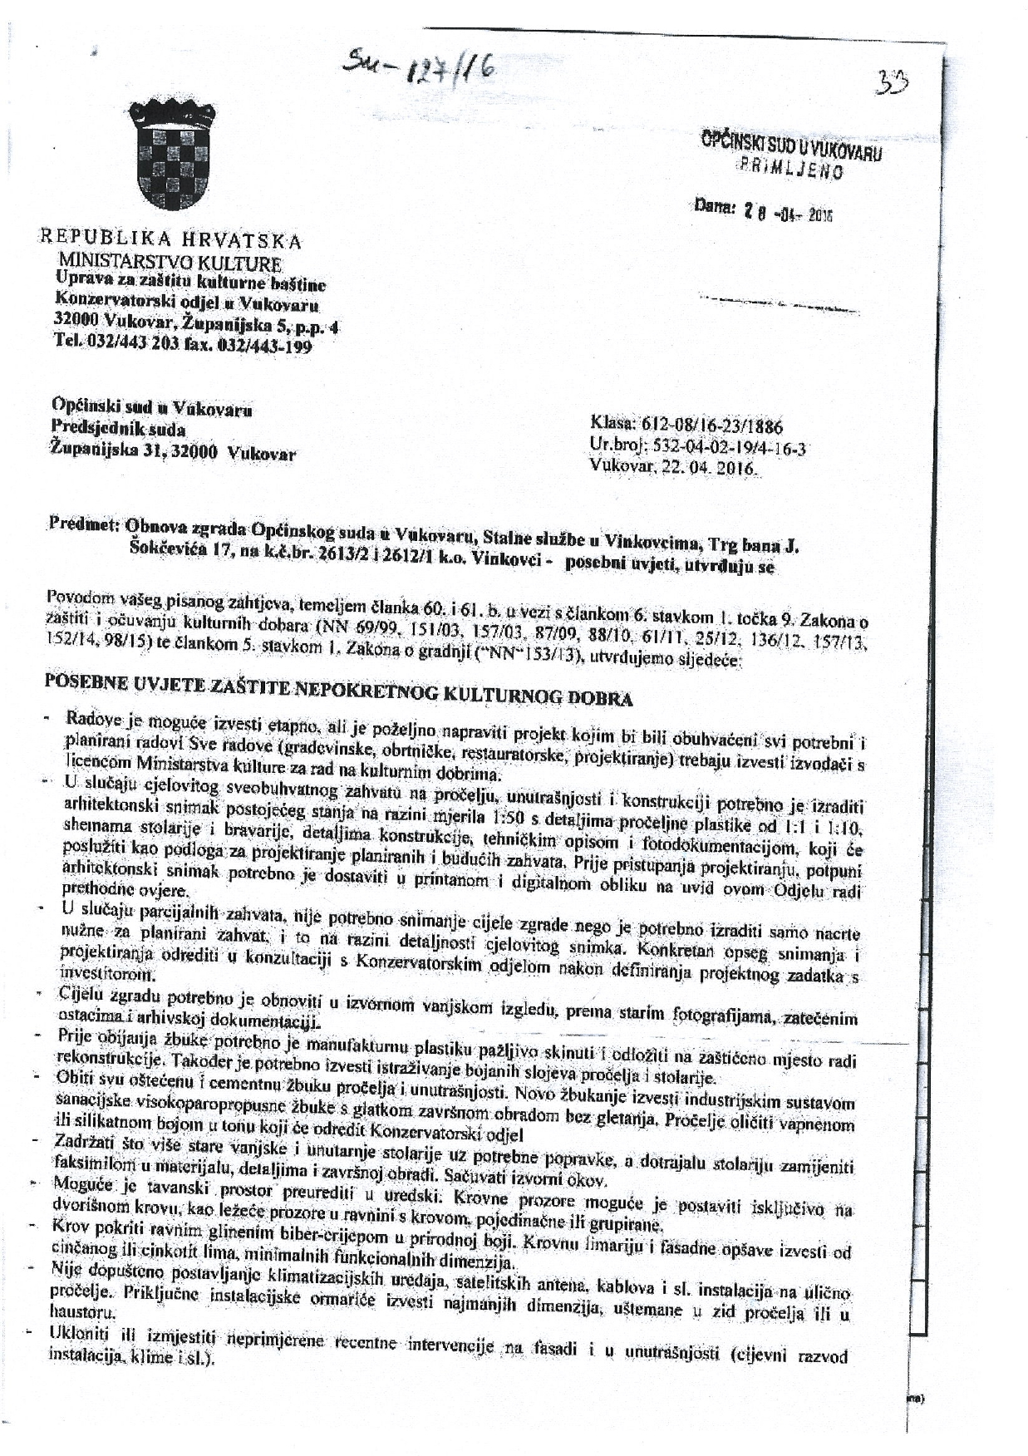
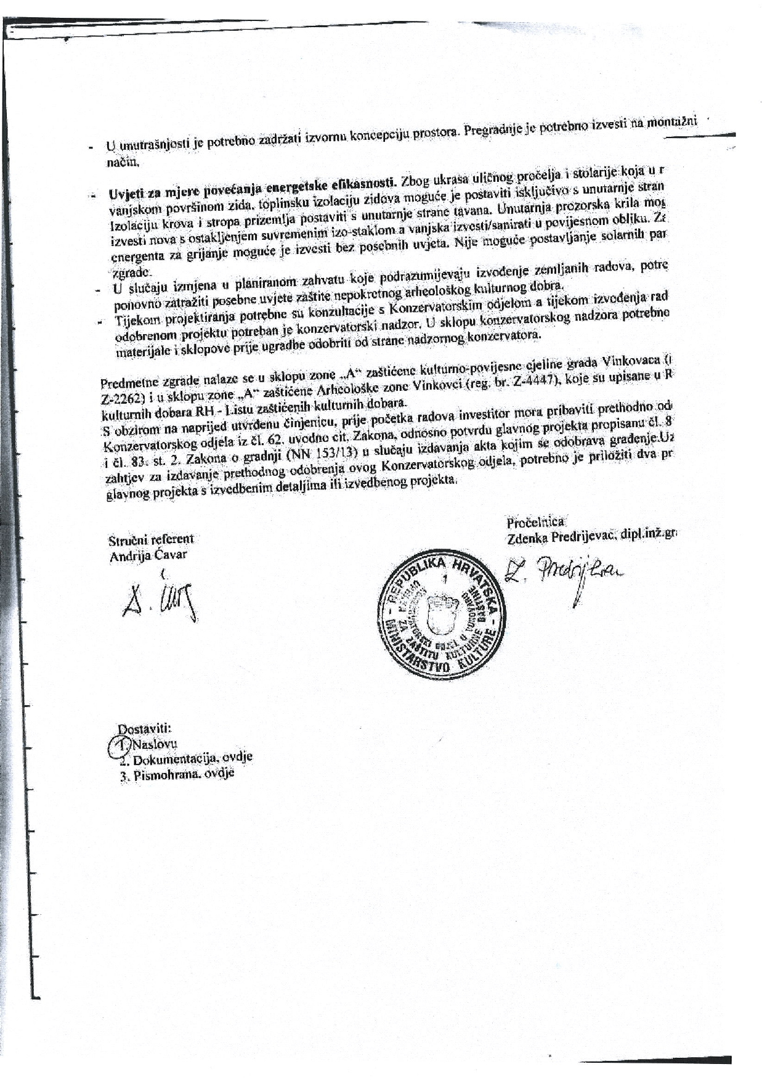

The building of the Municipal Court is located within zone "A" of the protected cultural and historical unit of the city of Vinkovci and within zone "A" of the protected Archaeological zone Vinkovci (reg. No. Z-447) which are entered in the Register of Cultural Property - List of Protected Cultural Property.
Land acquisitions includes displacement of people, change of livelihood encroachment on private property this is to land that is purchased/transferred and affects people who are living and/or squatters and/or operate a business (kiosks) on land that is being acquired.
Toxic/hazardous material includes any substance or chemical which is a "health hazard" or "physical hazard", including: chemicals which are carcinogens, toxic agents, irritants, corrosives, sensitizers; agents which act on the hematopoietic system; agents which damage the lungs, skin, eyes, or mucous membranes; chemicals which are combustible, explosive, flammable, oxidizers, pyrophoric, unstable-reactive or water-reactive; and chemicals which in the course of normal handling, use, or storage may produce or release dusts, gases, fumes, vapours, mists or smoke which may have any of the previously mentioned characteristics.
According to the existing Law on Areas and Seats of the Courts (OG 67/2018) and available data on the population of the Central Bureau of Statistics (Census 2011), the Municipal Court in Vinkovci covers 125,466 inhabitants. 100 officials and civil servants work in the Municipal Court in Vinkovci daily. Until the end of June 2019, the Municipal Court received 12,248 cases.
See CHMP measures Table.

